**Scatterplot**

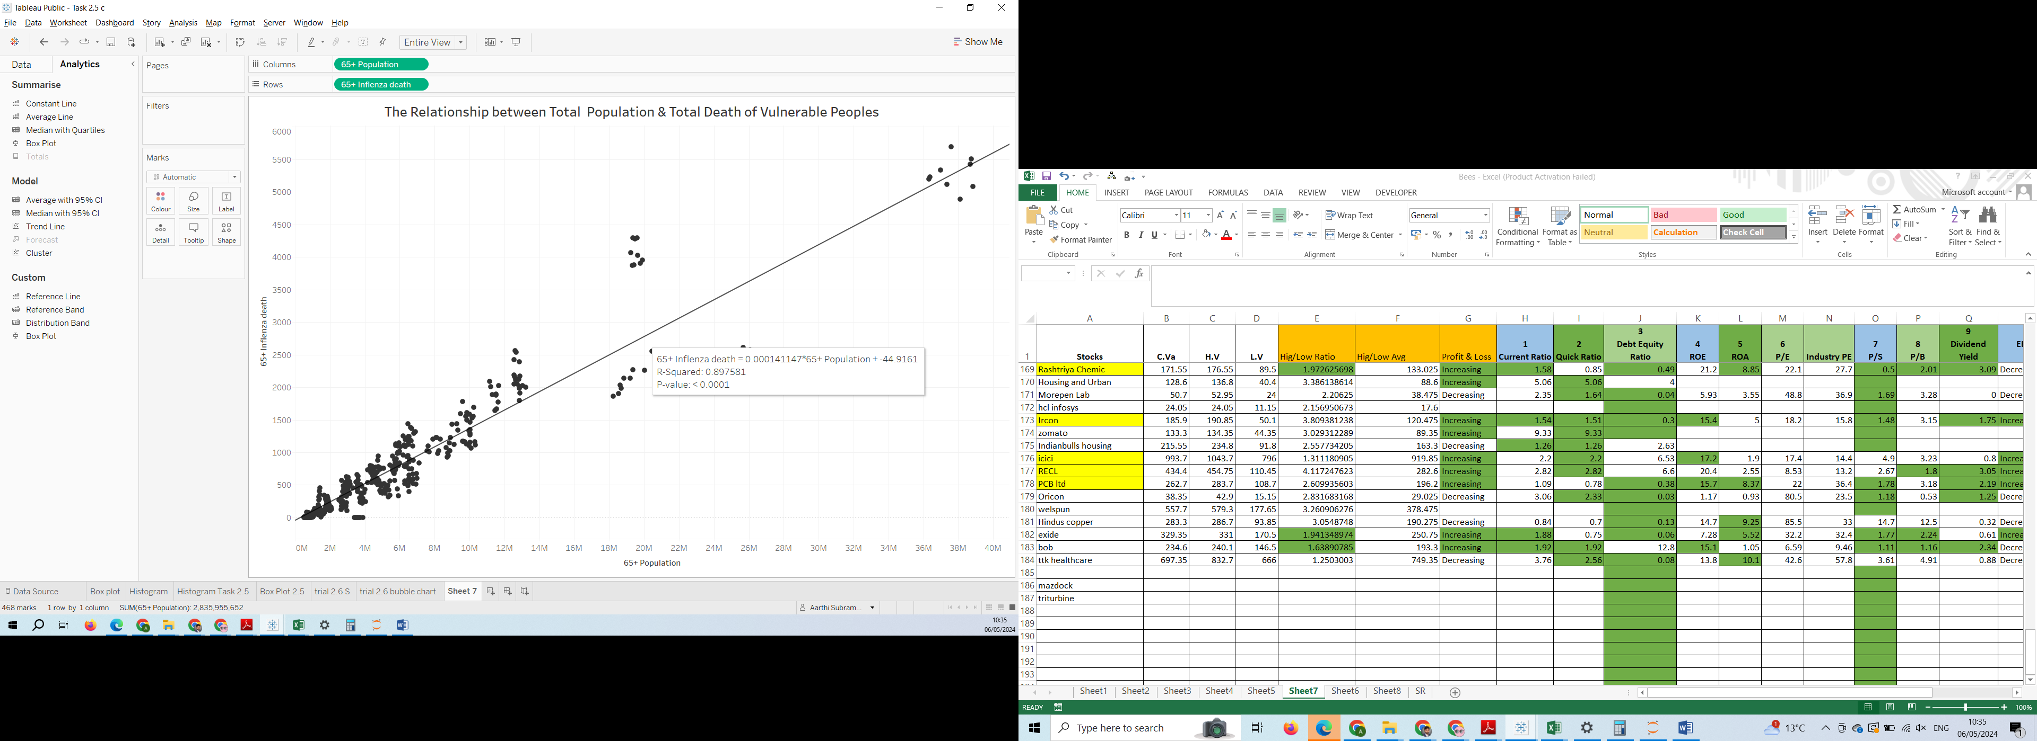

R-Squared: 0.897581, square root of this is 0.9474 which is same as Task 1.8 Correlation of 0.947407285.

Yes all the data values are tightly clustered, this has strong correlation, as vulnerable population increases death in vulnerable area also increase and also in reverse. This has positive correlation.

**Bubble Chart**

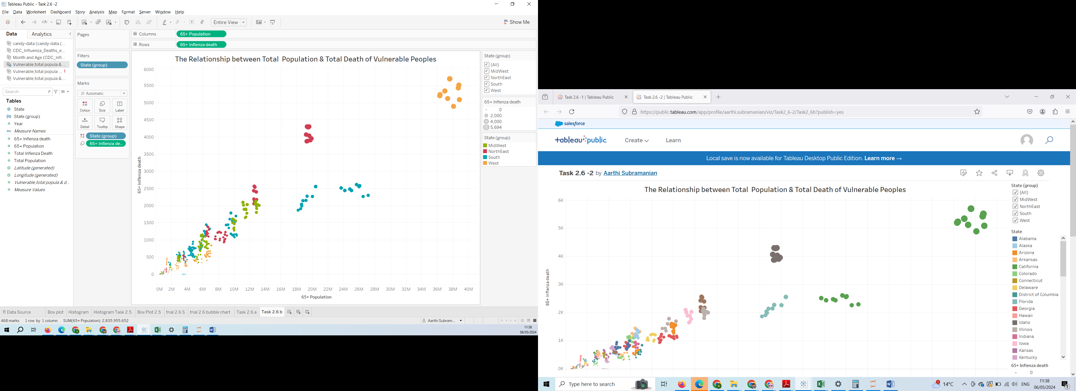

<https://public.tableau.com/app/profile/aarthi.subramanian/viz/Task2_6-1/Sheet7?publish=yes>

<https://public.tableau.com/app/profile/aarthi.subramanian/viz/Task2_6-2/Task2_6b?publish=yes>